Using GONet Electronic Data Transfer (EDT) With MedBASE

What is GONet Electronic Data Transfer (EDT)?

GONet EDT is a service provided by the Government of Ontario for securely transmitting electronic files. The Ministry of Health makes this service available to physician providers and medical billing agents for billing transactions. OHIP Submissions may be sent, and Claims Error Reports and OHIP Reconciliation Summaries received, via modem by using this electronic service.

Applying to MOH for EDT Service

Any provider or billing agent wishing to conduct billing through the Ministry of Health’s GONet EDT service must first apply to the ministry for a GONet EDT user account. This holds true even when a provider bills through an agent who is already approved to use the system: the provider must still obtain a user account from the ministry for his or her billing to be accepted through the billing agent’s user account.
To apply, simply fill out and sign the two forms entitled Application for GONet Electronic Data Transfer (EDT) Service and Electronic Data Transfer (EDT) Undertaking and Acknowledgement and mail them to:

EDT Registration
P.O. Box 68
Kingston, ON K7L 5K1

The Ministry will provide a GONet EDT User ID and Password once the application has been approved (normally 2 to 4 weeks).
For any issues relating to your GONet EDT account, please call the EDT toll free hotline at 1-800-262-6524.

Setting Up MedBASE for GONet EDT

To set up MedBASE for GONet EDT service, you need a modem connected to your computer and your GONet EDT User ID and Password.

- From the MedBASE Main Screen, select Process .
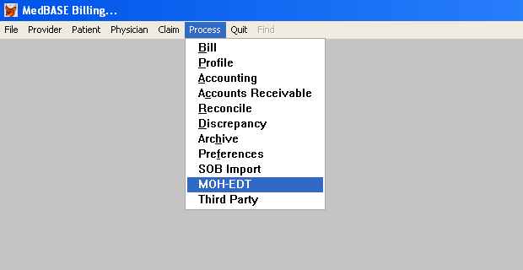

- From the Process menu, select MOH-EDT . The MOH EDT screen will appear.

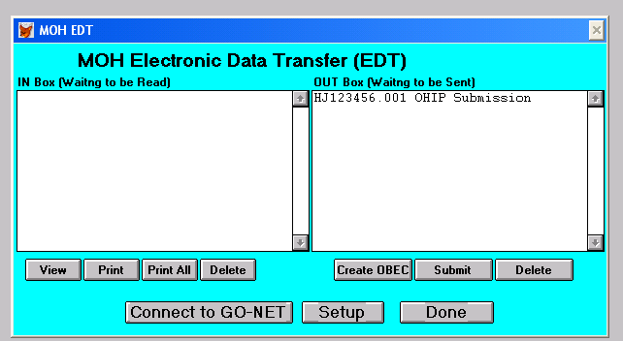

- Select Setup . The EDT/HCV Setup screen will appear.

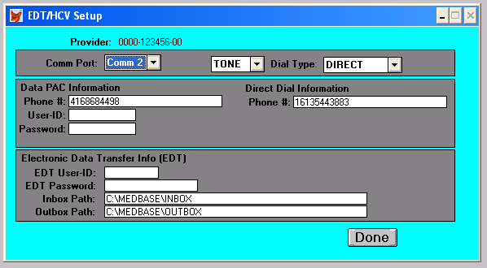

- From the Comm Port dropdown list, select the port associated with your modem.
- If you are using a DATAPAC connection, select DATAPAC from the Dial Type dropdown list; otherwise, leave it as DIRECT. DATAPAC users should enter their DATAPAC User ID and Password in the appropriate fields under DATAPAC Information.
- Note that MedBASE automatically supplies the phone numbers to connect to EDT through both DATAPAC and direct dial. Should these numbers be missing, they must be entered as follows (with a “1” at the beginning if long distance):
Direct: 6135443883
DATAPAC: 4168684498
- Under Electronic Data Transfer Info (EDT), enter your GONet EDT User ID and Password. Note: if this is the first time you are using you EDT account, you can find your User ID and Password on the account information sheet sent to you by the Ministry when your account was activated. Your User ID (beginning with “MOH”) will always remain the same, but you will be prompted to change your password the first time you log on to GONet EDT, and occasionally thereafter. Whenever you are prompted to change your password, ensure that you enter the change on the MedBASE EDT/HCV Setup screen prior to the next time you connect to EDT. For any issues relating to your User ID or Password, contact the EDT toll free helpline at 1-800-262-6524.
- Select Done  to return to the MOH EDT screen.

Creating an EDT Submission

- From the MedBASE Main Screen, select Process .
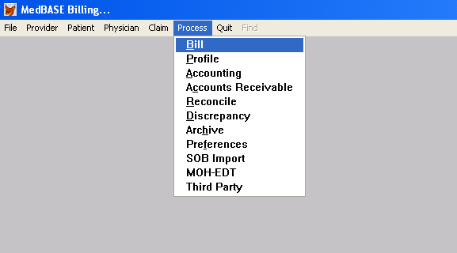

- From the Process menu, select Bill . The OHIP Submission screen will appear.
- Select F7-Bill .
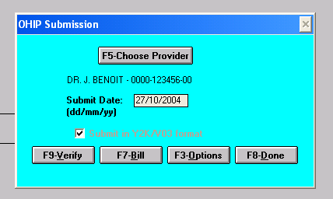

- A screen will appear that reads: “STOP! WARNING!! This function will process and submit all unsubmitted OHIP, Reciprocal, and WCB claims. Do you wish to proceed?” Select Yes .
- A screen will appear that reads: “Where would you like to put the Submission File?” Select EDT Out Box .
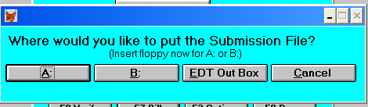

- A screen will appear that reads: “Would you like to print a Submission Summary?” Check off whichever summary type you would like and select your desired print option.
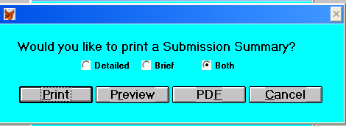

- A screen will appear advising you of the number of claims and records included in the new submission filed. Select OK . Your submission is now ready for transfer to the Ministry of Health.

Sending Submission Files to MOH Using EDT

- From the MedBASE Main Screen, select Process .
- From the Process menu, select MOH-EDT . The MOH EDT screen will appear. Submission files ready for transfer to the Ministry of Health will be listed in the OUT Box column on the right hand side.

- Select Connect to GO-NET . The modem will connect to the GONet EDT site. If you did not enter your MOH User ID and Password on the MedBASE EDT/HCV setup screen (see Setting Up MedBASE for GONet EDT above) you will be prompted to log on. Type your User ID and press Enter . You will be prompted for your password. Type your current EDT Password (for security reasons, it will not appear on the screen as you type). Press Enter .
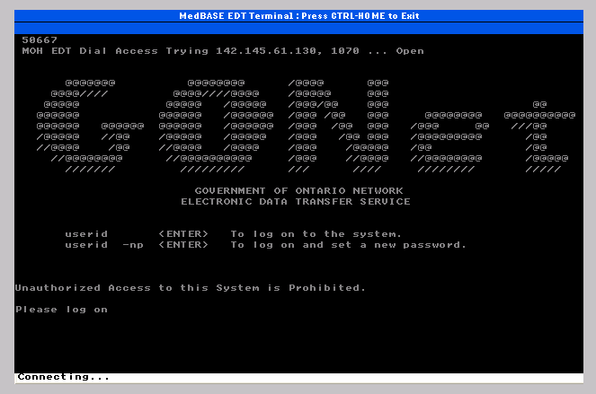

Note: if this is the first time you are using you EDT account, you can find your User ID and Password on the account information sheet sent to you by the Ministry when your account was activated. Your User ID (beginning with “MOH”) will always remain the same, but you will be prompted to change your password from time to time. Whenever you are prompted to change your password, ensure that you enter the change on the MedBASE EDT/HCV Setup screen prior to the next time you connect to EDT (see Setting Up MedBASE for GONet EDT above). For any issues relating to your User ID or Password, contact the EDT toll free helpline at 1-800-262-6524.
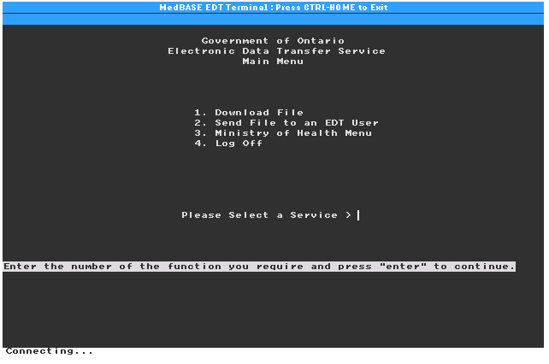
- On the GONet EDT Main Menu, enter 3 for Ministry of Health Menu.
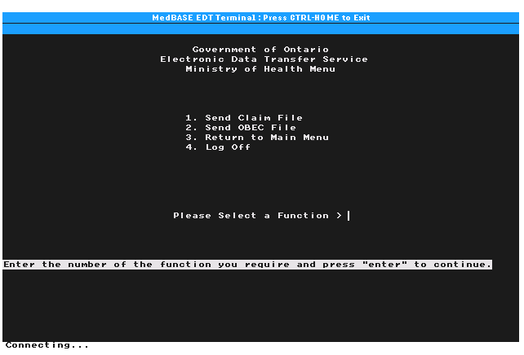
- On the Ministry of Health Menu, enter 1 for Send Claim File.
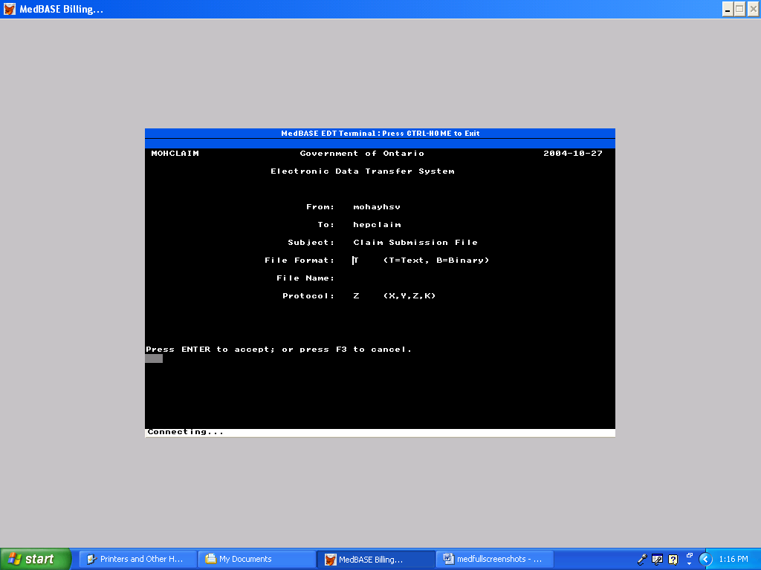
- Under File Format on the Send Claim File Screen, enter T for Text. Under File Name, enter your submission file name as it appears in the top left corner of the corresponding MedBASE Billing Summary printout. Press F11 to begin file transfer. A message should appear: “Please begin your upload now”.
- Once transfer of submission files has finished, enter 4 for Return to Main Menu. If you wish to close the EDT connection, enter 4 again on the GONet EDT Main Menu to exit. You will be returned to the MedBASE MOH EDT Screen. Note that you will be automatically logged out of the EDT connection if there is no activity for more than 30 seconds.

Retrieving Reports from MOH Using GONet EDT

- On the MedBASE Main Screen, select Process .
- From the Process menu, select MOH-EDT . The MOH EDT screen will appear.

- Select Connect to GO-NET . The modem will connect to the GONet EDT site. If you are prompted to change your password, ensure that you enter the change on the MedBASE EDT/HCV Setup screen prior to the next time you connect to EDT (see Changing Your EDT Password in MedBASE below).
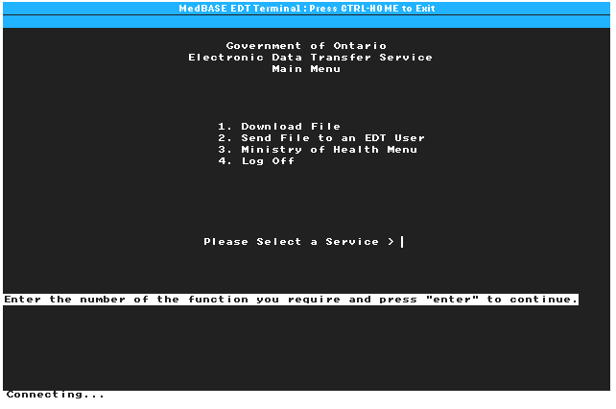
- On the GONet EDT Main Menu, enter 1 for Download. Files available for download will be listed with a “U” (indicating “Undelivered”) in the leftmost column (those already retrieved will appear with a “D”, indicating “Delivered”, in this column).
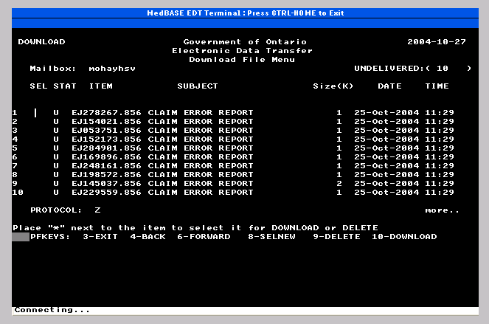
- To select files for download, press F8 . An asterisk (*) will appear to the left of the first ten available files. Press F10 to commence the download.
- Repeat Steps 4 and 5 above until all available files have been downloaded.
- If you wish to close the EDT connection, enter 4 on the GONet EDT Main Menu to exit. You will be returned to the MedBASE MOH EDT Screen. The files you have downloaded should appear in the left hand IN Box column on this screen.

Printing Downloaded MOH EDT Reports

The instructions in this section may be used for printing the following reports downloaded from the Ministry of Health through EDT:

-EDT Batch Acknowledgments
-OHIP Claims Error Reports

The processing of OHIP Reconciliation Summary (“Remittance Advice” or “RA”) files is covered in the section Processing Downloaded OHIP Reconciliation Summaries below.
In order to print EDT Batch Acknowledgments and OHIP Claims Error Reports downloaded in the MedBASE EDT IN Box, follow the steps below.

- On the MedBASE Main Screen, select Process .
- From the Process menu, select MOH-EDT . The MOH EDT screen will appear. The files you have downloaded should appear in the left hand IN Box column on this screen.
EH123456.001
PH123456.001
BH123456.001

- To print a single file, select the file by left-clicking with the mouse and select Print  at the bottom of the screen. If you wish to print all available files in the IN Box, simply select Print All . MedBASE will print the selected files.

Processing OHIP Reconciliation (“Remittance Advice”) Files Downloaded from GONet EDT

- On the MedBASE Main Screen, select Process .
- From the Process menu, select Reconcile . A new screen will appear that includes the words “Insert your first Reconciliation disk and choose the drive”. Select EDT Inbox . A new screen will open.
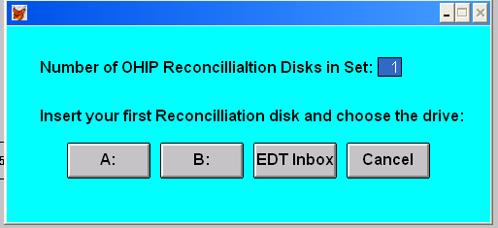

- Choose desired Reconciliation file(s) from the list in the left hand column and select Open .
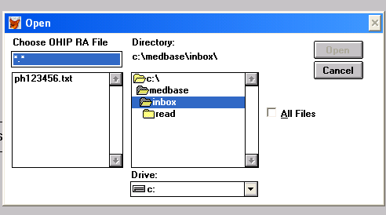
- A screen will appear reading, “OHIP Reconciliation in Progress”. Change underpayment and overpayment acceptance thresholds if desired. Select Continue .
- A screen will prompt you to choose which OHIP Reconciliation reports to print. Select desired reports.
- Select Done  when reconciliation finishes.

