MC EDT Manual for MedBASE Users

Sending Submission Files

Open Internet Explorer
Go to the address https://www.edt.health.gov.on.ca/

Enter Go Secure ID (email address) and Password

Click Sign In

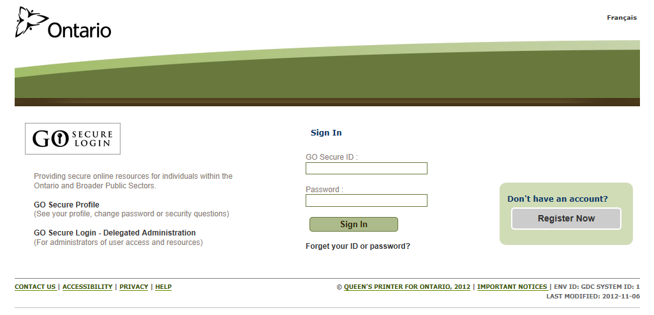

Click on MC EDT Service (Upload / Download)

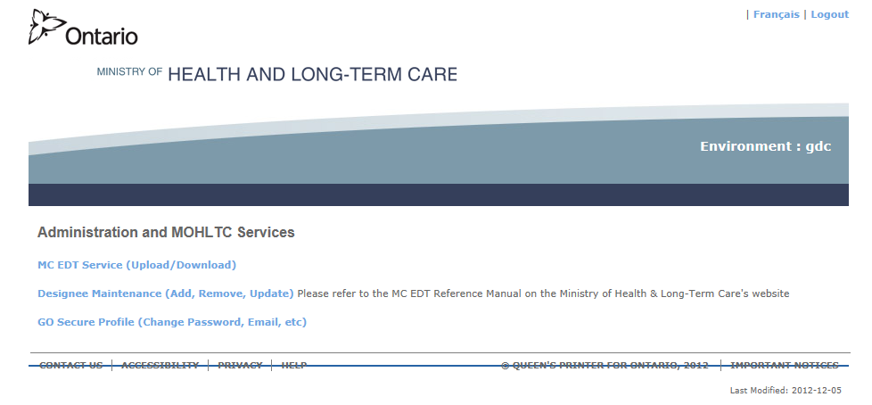

Click on Upload

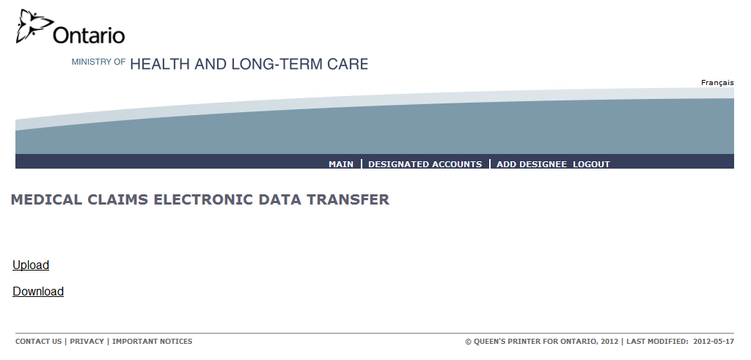

Select your Billing Number from the drop down list
Choose Claim File for ‘Select File Type’
Click Browse

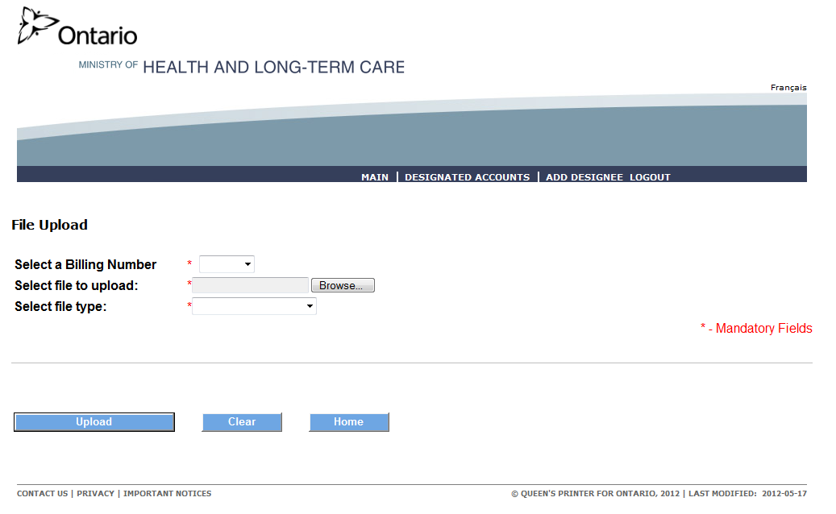

Navigate to your MedBASE OUTBOX (usually C:\MEDBASE\OUTBOX)

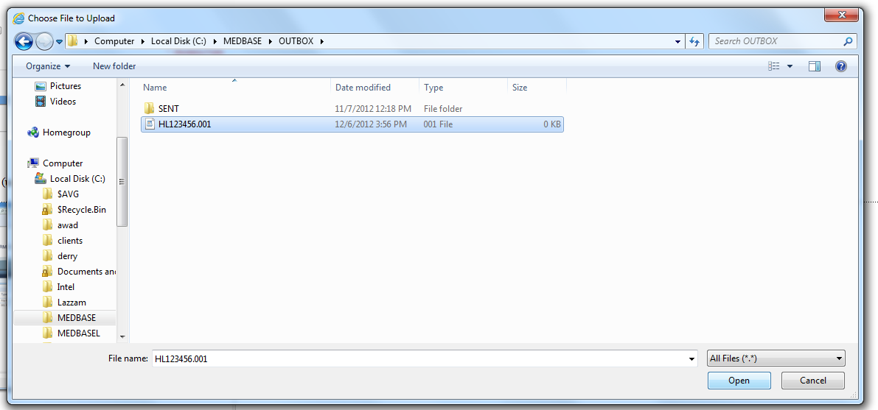

Highlight the Submission file (starts with an ‘H’) and click Open

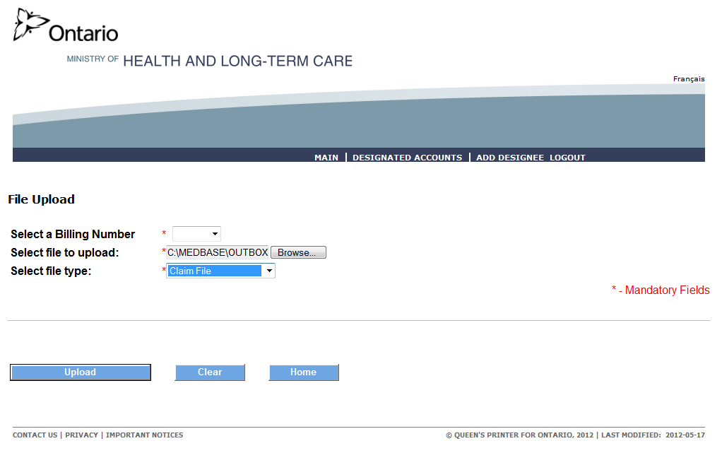

Click Upload

Downloading Report Files

Open Internet Explorer
Go to the address https://www.edt.health.gov.on.ca/

Enter Go Secure ID (email address) and Password

Click Sign In

Click on MC EDT Service (Upload / Download)

Click on Download

Select your Billing Number from the drop down list
Choose Claim File for ‘Select File Type’
Click Browse

Select your Billing Number from the dropdown list
Click Download

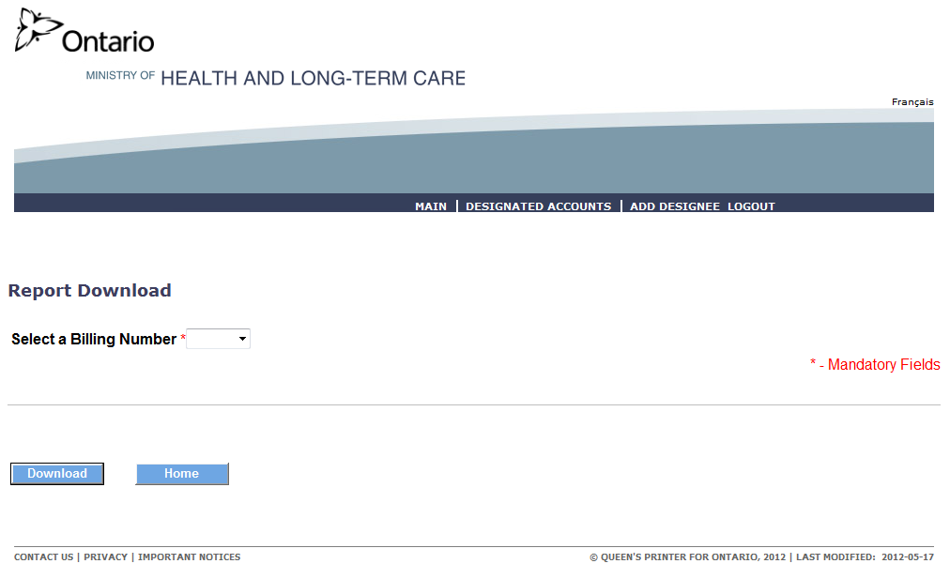

You must download each file one at a time.

Click on the word Download beside a file

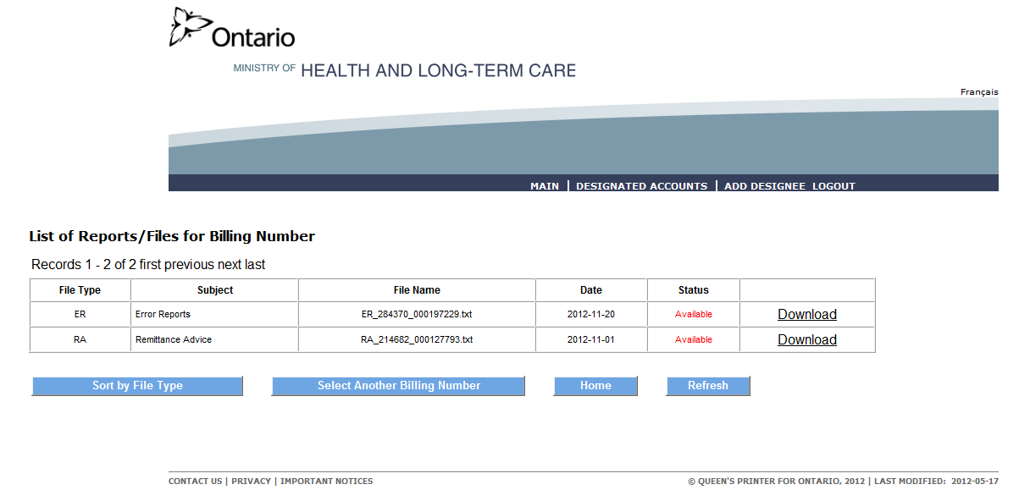

On the Internet Explorer Save Dropdown choose Save As
Navigate to your MedBASE Inbox (usually C:\MEDBASE\INBOX)
Click Save
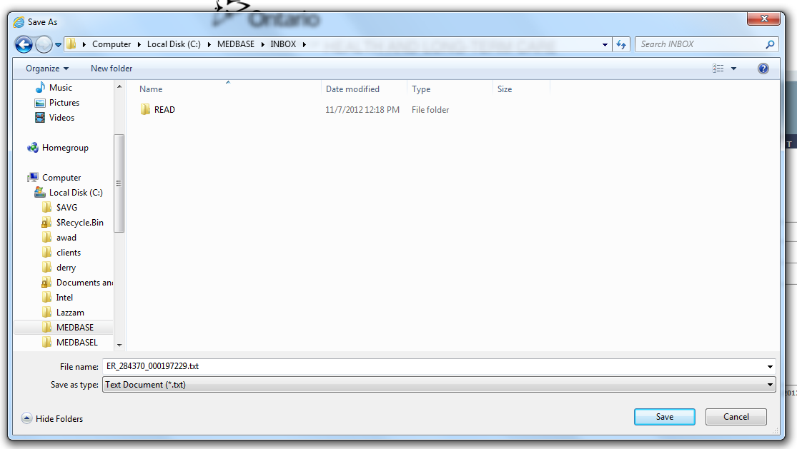

Repeat the steps above for each new file listed on the download page.

You can now log out of MC EDT and return to MedBASE to process the EDT files.

